# Top 5 Causes of Death

| **Mortality Code** | **Cause of Death** | **Number of Deaths** | **Percentage** |
| --- | --- | --- | --- |
| C00-D48 | Neoplasms (tumors) | 13235 | 32.78% |
| I00-I99 | Diseases of circulatory system | 11871 | 29.40% |
| V01-Y89 | External causes (accidents, self-harm, medical procedures, etc.) | 3478 | 8.61% |
| J00-J98 | Diseases of respiratory system | 2651 | 6.57% |
| K00-K92 | Diseases of digestive system | 1800 | 4.46% |

Top 5 causes of death accounts for 33,035 deaths or 81.82% of total deaths (40376)

Deaths Per Year for Each Cause of Death (Top 5)

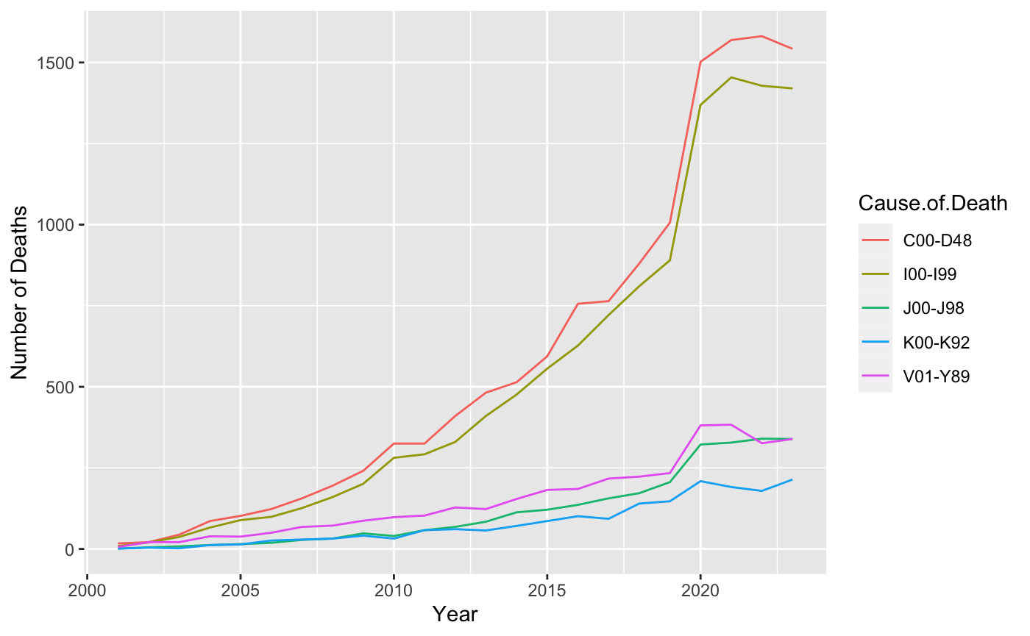

Policy Type

| **Policy Type** | **Count** |
| --- | --- |
| Single Premium Whole Life | 371,301 |
| 20-year Term Life | 607,281 |

Male vs. Female

| **Sex** | **Count** |
| --- | --- |
| Male | 547,146 |
| Female | 431,436 |

Smoker Status

| **Smoker Status** | **Count** | **Percentage** |
| --- | --- | --- |
| Smoker | 61,740 | 6.3% |
| Non-Smoker | 916,842 | 93.7% |

Population

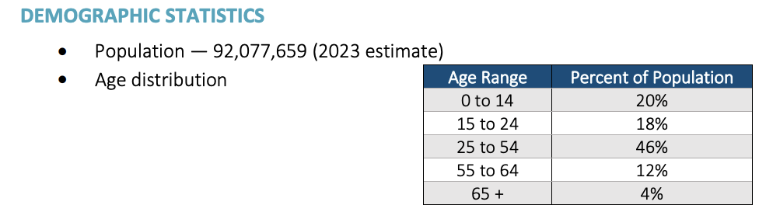

Age at Issue Breakdown from Inforce Data Set - Total of 978,582

| **Age Range** | **Number** | **Percentage** |
| --- | --- | --- |
| 0 to 14 | 0 | 0% |
| 15 to 24 | 0 | 0% |
| 25 to 54 | 826,486 | 84.46% |
| 55 to 64 | 140,266 | 14.33% |
| 65+ | 11,830 | 1.21% |

Overall Underwriting Class Breakdown (total of 978,582)

| **Underwriting Class** | **Number** | **Percentage** |
| --- | --- | --- |
| Very low risk | 357,839 | 36.57% |
| Low risk | 275,681 | 28.17% |
| Moderate risk | 233,006 | 23.81% |
| High risk | 112,056 | 11.45% |

25 to 54 Underwriting Class Breakdown (total of 826,486)

| **Underwriting Class** | **Number** | **Percentage** |
| --- | --- | --- |
| Very low risk | 301,318 | 36.46% |
| Low risk | 231,902 | 28.06% |
| Moderate risk | 197,878 | 23.94% |
| High risk | 95,388 | 11.54% |

55 to 64 Underwriting Class Breakdown (total of 140,266)

| **Underwriting Class** | **Number** | **Percentage** |
| --- | --- | --- |
| Very low risk | 52,226 | 37.23% |
| Low risk | 40,440 | 28.83% |
| Moderate risk | 32,253 | 22.99% |
| High risk | 15,347 | 10.94% |

65+ Underwriting Class Breakdown (total of 11,830)

| **Underwriting Class** | **Number** | **Percentage** |
| --- | --- | --- |
| Very low risk | 4,295 | 36.31% |
| Low risk | 3,339 | 28.22% |
| Moderate risk | 2,875 | 24.30% |
| High risk | 1,321 | 11.17% |

Overall Urban vs. Rural (total of 978,582)

| **Area** | **Number** | **Percentage** |
| --- | --- | --- |
| Urban | 620,468 | 63.40% |
| Rural | 358,114 | 36.60% |

24 to 54 Urban vs. Rural (total of 826,486)

| **Area** | **Number** | **Percentage** |
| --- | --- | --- |
| Urban | 523,477 | 63.34% |
| Rural | 303,009 | 36.66% |

55 to 64 Urban vs. Rural (total of 140,266)

| **Area** | **Number** | **Percentage** |
| --- | --- | --- |
| Urban | 89,470 | 63.79% |
| Rural | 50,796 | 36.21% |

65+ Urban vs. Rural (total of 11,830)

| **Area** | **Number** | **Percentage** |
| --- | --- | --- |
| Urban | 7,521 | 63.58% |
| Rural | 4,309 | 36.42% |

Takeaways

* Top 5 causes of death accounts for 33,035 deaths or 81.82% of total deaths (40376)
  + Tumors, diseases of circulatory system, external causes, diseases of respiratory system, diseases of digestive system
  + Deaths related to tumors and diseases of circulatory system have increased most rapidly over the past since 2000
* ⅔ of inforce policies are 20-year term life and ⅓ are single premium whole life
* 56% of inforce policies are held by males and 44% by females
* 93.6% of inforce policy holders are non-smokers
* 84.46% of inforce policy holders are in the 25-54 age range
* Overall, policyholders are very low risk, low risk, moderate risk by UW class
* About 63% of policyholders live in urban areas compared to rural
* Exchange rate — Lumarian Č 1.743 = US $ 1

Thoughts

* Possible incentive programs
  + Fitness tracking incentives
  + Annual health check-ups
  + Heart health screenings
  + Genetic testing
  + Cancer prevention initiatives
  + Incentives for preventative screenings
  + Holistic nutrition education

Incentive Programs Based on Age/Job

* Causes of death based on age
* Different causes of death by each region
* Literature review - life and health insurance companies that have incentive programs
  + Life insurance pricing methodologies